
Physician Finder Guide

….
- What Is the Physician Finder?
Physician Finder is a tool for patients to search for physicians in their area who are trained in the Acessa® procedure. The Finder utilizes individual profile pages of physicians hosted on the Hologic site, each composed of a headshot, biography, practice location, and contact information. When a prospective patient inputs their zip code on the site, profiles of Acessa-trained physicians and respective practices closest to them are populated. Physician Finder is often shared across Hologic’s social channels, making it a great tool for connecting patients with physicians. Follow the steps below to create a profile on the Physician Finder.

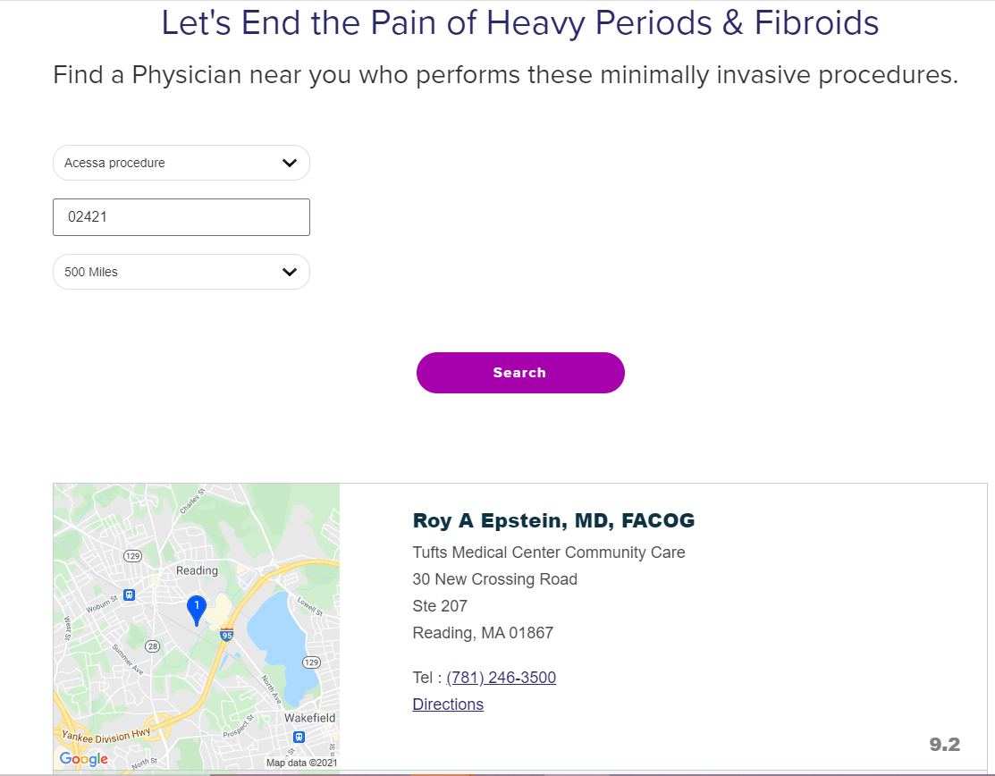

2.0 Signing Up for the Physician Finder
If you aren’t already part of the Physician Finder, we recommend you follow the below steps to get added.
- Fill out the Physician Finder Sign Up form: This form collects relevant information like practice location, phone number, and website that our internal team will utilize to set up your profile.
If you have any questions, you can contact your sales representative to help or email HologicSurgical@Hologic.com.

